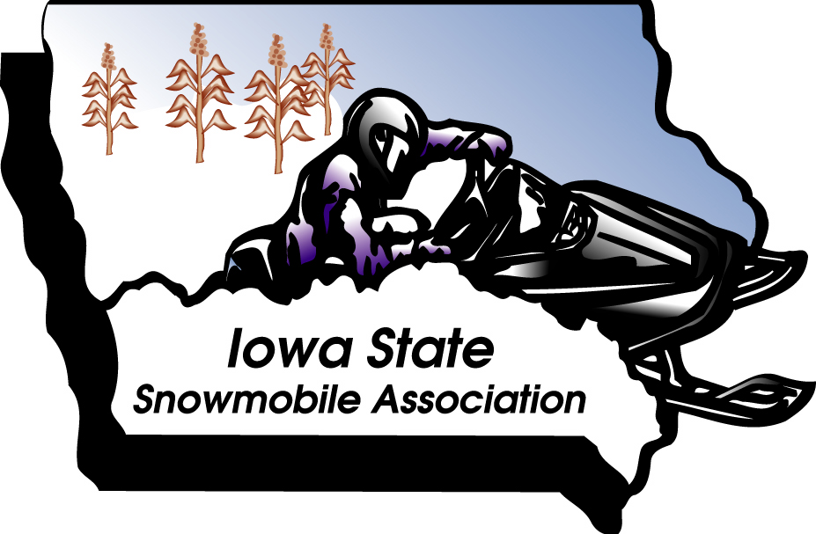
1973 - 2013
40th Anniversary
2013 ISSA Club of the Year Nomination
- When answering Yes and No, or frequency questions please underline and or BOLD your answer.
- Supporting documentation may be scanned and sent as an attachment. Please note which question the document applies to by writing the question number at the top of the document. You can also list the document name in the explanation section of the form, or attach it as a hard copy.
- Digital photos may be inserted at end or sent as separate attachment. Note relationship to number of question it is in response too.
Club Name:

- Current # of Members: ___________
- Does your club host a landowner appreciation function? Yes No
Frequency held? Yearly, Every Two Years, Other: ____________________
If yes explain type of function held? Attach a copy of your invite. Photos are optional.

Club Name:

- Has there been any media coverage (newspaper, TV, radio) on snowmobiling events that highlighted or included information about your club? Yes or No
If yes explain what/why below. Include copies of news articles or pictures printed in newspaper.

- Is your club or any members on call/or standby as part of your counties/city Snow Emergency Plan? Yes or No
- Number of members on counties emergency call rooster: _______________
- Provide documentation i.e.: EMA response maps, letter of participation, copy of contact information provided by club to emergency agencies.

- Does your club promote and hold snowmobile safety classes on a regular frequency? Yes or No
- Frequency (BOLD or underline answer): once a year, once every other year, only when youth/parent request a class.
- How did you promote/announce your snowmobile safety class i.e.: DNR Website, Club newsletters, newspaper articles, posters, ISSA Magazine, ISSA Website, Facebook or other? Please explain below and share examples of notification.

Club Name:

6. Did your Club or any member of your club submit a letter of nomination for any of the six ISSA Awards listed below: (BOLD or underline answer?)
Yes or No | Dealer of the Year:
Yes or No | Snowmobiler of the Year
Yes or No | Snowmobile Family of the Year
Yes or No | Groomer of the Year:
Yes or No | Lady Snowmobiler of the Year
Yes or No | Young Adult of the Year

7. Did your club complete and submit their annual Charity report? Yes or No
Is this the first year that your club submitted a Charity Report? Yes or No

8. Did your club raise funds or provide manpower for any local/community charities?
i.e.: Food Drives, Toys for Tots, Youth Programs, Community Improvement Projects, or
Scholarship Programs, including the ISSA Scholarship Foundation. Explain what your club
did, provide copies of news articles, or pictures to support your answer:

9. Has your club donated to the ISSA Club Challenge (Legislative Fund)? Yes or No
- Was this your clubs 1st donation to the ISSA Club Challenge? Yes or No
- If NO, does your club donate to the ISSA Club Challenge yearly? Yes or No

10. Has your club donated to the ISSA Charity fund for Spina Bifida of Iowa? Yes or No
- Was this your clubs 1st donation for Spina Bifida? Yes or No
- If NO, does your club donate to Spina Bifida on a yearly basis? Yes or No

Club Name:

11. Has your club submitted a bid to host the ISSA Campout? Yes or No
- Has your club been awarded the ISSA Campout bid? Yes or No
- If awarded the campout bid where was campout held?

12. What efforts/promotions has your club done to try and raise club memberships in the past year? Please explain below and submit examples:
- Is your club 100% ISSA membership? Yes or No Attach a copy of club bylaws
- Does your club encourage all new members to be ISSA Members? Yes or No
- Does your club provide education to new members on what the ISSA provides clubs and members? i.e.: Insurance, signs, equipment, Lobbyist to protect our rights etc.
Yes or No

13. Does your club have members that attend the annual ISSA Convention? Yes or No
- Did your club have a booth at ISSA Convention? Yes or No

14. Does your club have members that attend the annual ISSA Campout? Yes or No

15. How does your club connect with your members or other snowmobilers?
- Does your club have newsletters? Yes or No
- Does your club use email? Yes or No
- Does your club have a facebook account? Yes or No
- What is your clubs facebook name? ________________________________________
- Does your club have an established Website? Yes or No
- What is your club website address/name?_____________________________________
- Does your clubs website have a link to the ISSA Website? Yes or No
- Does your clubs website have links to other snowmobile related sites? Yes or No
- Are your clubs forms available to your membership via the website? Yes or No
Club Name:

Question 15 continued:

Please list and describe other examples your club uses to connect with members.

16. Did your club submit a news article or letter to be printed in the Iowa Snowmobiler Magazine during the snow season of 12/13? Yes or No
What was the name of the article? ______________________________________
Which issue was it printed in? __________________________________________

17. Do member(s) of your club attend any regular scheduled ISSA board meeting? Yes or NO
If yes what board meetings did he/she/they attend?

18. How many months out of the year does your club meet? ____________ Months
19. Please indicate the type of activities your club has held, during the year to keep members involved? We are interested in events held both during the snow season as well as events in held in the off season.

Club Swap Meets Yes or No
Regional club meetings or get together Yes or No
Trail development days Yes or No
Bridge building events Yes or No
Sponsorship drives for maps and/or websites Yes or No
Club rides, fun runs, supper rides Yes or No
Hold a local club campout(s) or attend ISSA campout as a club Yes or No
Club cookouts or potlucks Yes or No
Club trips/outing Yes or No
Club parade entries Yes or No

Club Name:

Question 19 continued:
Did your club assist with any community projects Yes or No
Does your club have a fair booth Yes or No
Does your club attends or participates in other power sport events Yes or No

Provide copies of your clubs event calendar, email notice(s), flyers or newsletters articles or pictures of events.

Provide a brief description of the event(s) that your club has found most effective in getting /keeping members involved or unique events you would like to share with other clubs.

THANK YOU FOR TAKING THE TIME TO SUBMIT YOUR 2013 CLUB OF THE YEAR APPLICATION.

