Iowa State Snowmobile Association
2013
Snowmobile Family of the Year Nomination

Nomination forms are located on the ISSA website at: iowasnowmobiler.com

Requirements:
  - Nominations are to be typed or printed – hand written nominations will not be judged
  - Nominee(s) must be a member(s) in good standing with the ISSA
  - A photo of the nominee(s) must be included, digital photos are preferred but a hard copy photo is acceptable if a digital photo cannot be acquired.
  - Completed Nominations will be accepted via email (preferred) or US Mail.
  - Nominations must be received electronically or post marked by June 1, 2013. Nominations received after the June 1, 2013 deadline will not be judged.
  - When submitting nominations by email send email using a "Delivery Receipt and a Read Receipt". These receipts will be your confirmation that the Award Committee has both received and read your nomination. If you do not receive a Delivery/Read Receipt back please verify the email address you sent too and resend.

Name of Nominees:
Address:
City/State/Zip:
Phone:
E-mail:

Nominating Club/Person:
Contact Individual:
Address:
City/State/Zip:
Phone:
E-Mail

Nomination Instructions:

The Iowa State Snowmobile Association 2013 Snowmobile Family of the Year will be selected on the basis of their involvement in the sport. We will be judging nominations from all across Iowa.

Be sure to support your nominations with newspaper clippings, photos, videos, and letters of support from community members as well as any other information you think might be needed to help us make a reasonable and fair selection.

Snowmobiling activities that should be considered in this nomination include activities of the current and past seasons.

If more space is needed for any category, please continue on separate sheets.

Nominee's Name:________________________

1. Are your nominee’s members of a snowmobile club(s)? If yes, list club name(s) along with any offices held.

Yes _____ No _____

2. Are they active in membership recruitment in their present club? If yes, please explain:
Yes _____ No _____

3. Are they active in membership recruitment for ISSA? If yes, please explain.

Yes _____ No _____

4. Does your nominee family participate in local club/ state association fund-raising events?

- What has this family done to foster relationships within the general public and/or the business communities regarding snowmobiling?

- How long have they been involved in snowmobiling?

Nominee's Name:__________________________

- What involvement, if any, have they had with governmental agencies, officials or a legislative body?

- What has been their level of involvement in local, state and/or national snowmobile activities?

9. Describe any special projects that your nominees may be working on.

- Please explain in detail why your nominees should receive the prestigious ISSA “2013 SNOWMOBILE FAMILY OF THE YEAR” award.

11. Remember, if you think enough of your nominees to nominate them then please take the time to make their nomination worthwhile.

Return completed nominations to:

E-mail nominations to both email addresses listed below.

E-mail: snohawk101@ymail.com and scott4@iowatelecom.net
Dave Carmichael 319-610-5265 Mindy Scott 319-325-8917

or send by U.S. Mail to:

ISSA Awards
2212 190th Street
Tripoli, IA 50676-9686

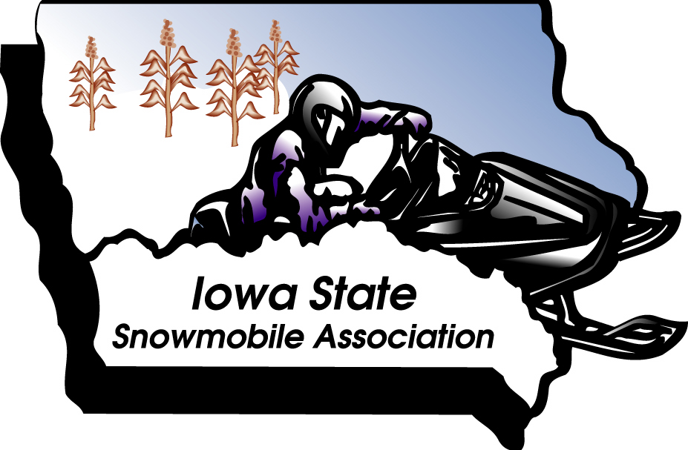

1973-2013

40th ANNIVERSARY

